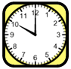
Name

Telling Time Worksheet
Draw Hands on the Clock

Look at each of the times below and draw the hour and minute hands on the clocks to show the correct time.

